02 Mach Day-12 Rag Agentic AI with Langgraph Part 2 (2.52.00)
Agenda:
- End to End project with Langgraph

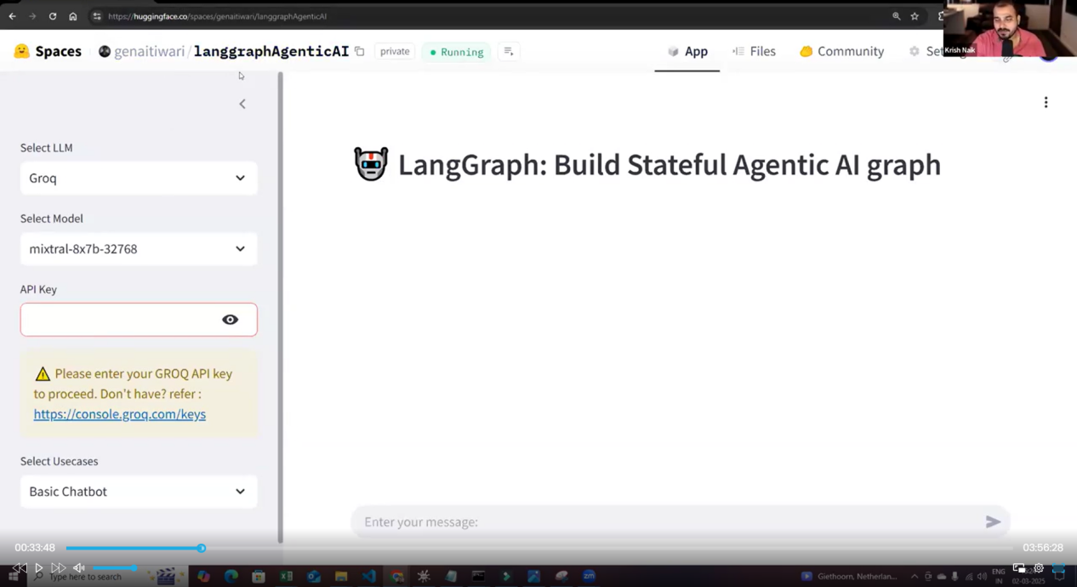

Modular Code : https://github.com/krishnaik06/Agentic-Ai-Project/tree/main
39.00.00
- Conda create -p venv python=3.12
- Adding requirements.txt with
langchain
langgraph
langchain_community
langchain_core
langchain_groq
langchain_openai
faiss-cpu
streamlit
tavily-python

- Conda activate venv/
- Pip install -r requirements.txt

- git init

- Create .gitignore file
Write venv/ in .gitignore so that heavy file wont go to git and save space. Any file which don’t needs to go to git should be added in .gitignore

- Create README.md file
- git add README.md

- Git add .
- git commit -m "first commit"

- git branch -M main

- git remote add origin https://github.com/VenuGurija/Agentic-AI-Project-AI-News-with-ChatBot.git

- git push -u origin main

48.30.00
Model Structure:

- Steps to create graph:
- Load llm
- Create graph structure with graphStructure.py file
- node.py file for nodes
- Tools like retreiver, arxivwiki etc in a .py file

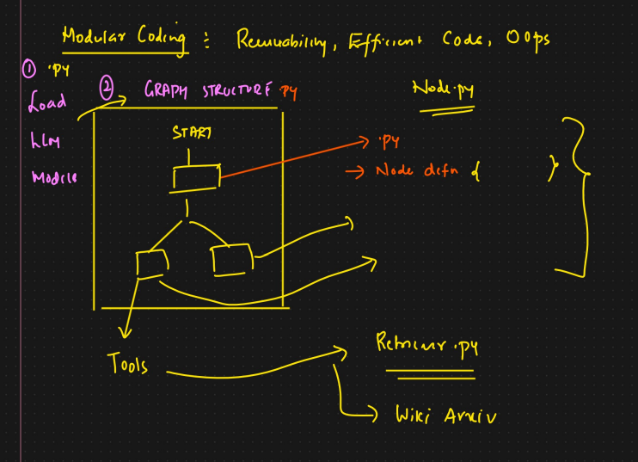

- Create src folder
- Create langgraphagenticai folder inside src
- Create LLMS folder inside langgraphagenticai
- Create graph folder inside langgraphagenticai
- Create __init__.py folder inside src, to make src folder as package, so that we can import things from src
- Create __init__.py inside langgraphagenticai folder
- Same create __init__.py files inside LLMS, graph
- Create tools folder inside langgraphagenticai and its __init__.py
- Create nodes folder inside langgraphagenticai and its __init__.py
- Create state folder inside langgraphagenticai and its __init__.py
- Create ui folder inside langgraphagenticai and its __init__.py
- Create vectorstore folder inside langgraphagenticai and its __init__.py
- Create main.py file inside langgraphagenticai
- Create openaillm.py file inside LLMS
- Create streamlitui folder inside ui
- Create loadui.py(to load ui), displayResult.py(result of action after clicking) file inside streamlitui
- Create uiconfigfile.ini (.ini is extension for config files) inside ui folder for config file to store elements inside field like llm names, llm models etc.

uiconfigfile.ini
[DEFAULT]
PAGE_TITLE = LangGraph: Build Stateful Agentic AI graph
LLM_OPTIONS = OpenAI
USECASE_OPTIONS = Basic Chatbot, Chatbot with Tool, AI News
GROQ_MODEL_OPTIONS = mixtral-8x7b-32768, llama3-8b-8192, llama3-70b-8192, gemma-7b-I, GPT-4o

- Create uiconfigfile.py inside ui folder to read configs
1.10.26

uiconfigfile.py
from configparser import ConfigParser

class Config:
def __init__(self,config_file="./src/langgraphagenticai/ui/uiconfigfile.ini"):
self.config=ConfigParser()
self.config.read(config_file)

def get_llm_options(self):
return self.config["DEFAULT"].get("LLM_OPTIONS").split(", ")

def get_usecase_options(self):
return self.config["DEFAULT"].get("USECASE_OPTIONS").split(", ")

def get_groq_model_options(self):
return self.config["DEFAULT"].get("GROQ_MODEL_OPTIONS").split(", ")

def get_page_title(self):
return self.config["DEFAULT"].get("PAGE_TITLE")

loadui.py

import streamlit as st
import os
from datetime import date

from langchain_core.messages import AIMessage,HumanMessage
from src.langgraphagenticai.ui.uiconfigfile import Config

class LoadStreamlitUI:
def __init__(self):
self.config = Config() # config
self.user_controls = {}

def initialize_session(self):
return {
"current_step": "requirements",
"requirements": "",
"user_stories": "",
"po_feedback": "",
"generated_code": "",
"review_feedback": "",
"decision": None
}

def load_streamlit_ui(self):
st.set_page_config(page_title= "🤖 " + self.config.get_page_title(), layout="wide")
st.header("🤖 " + self.config.get_page_title())
st.session_state.timeframe = ''
st.session_state.IsFetchButtonClicked = False
st.session_state.IsSDLC = False

with st.sidebar:
# Get options from config
llm_options = self.config.get_llm_options()
usecase_options = self.config.get_usecase_options()

# LLM selection
self.user_controls["selected_llm"] = st.selectbox("Select LLM", llm_options)

if self.user_controls["selected_llm"] == 'Groq':
# Model selection
model_options = self.config.get_groq_model_options()
self.user_controls["selected_groq_model"] = st.selectbox("Select Model", model_options)
# API key input
self.user_controls["GROQ_API_KEY"] = st.session_state["GROQ_API_KEY"] = st.text_input("API Key",
type="password")
# Validate API key
if not self.user_controls["GROQ_API_KEY"]:
st.warning("⚠️ Please enter your GROQ API key to proceed. Don't have? refer : https://console.groq.com/keys ")

# Use case selection
self.user_controls["selected_usecase"] = st.selectbox("Select Usecases", usecase_options)

if self.user_controls["selected_usecase"] =="Chatbot with Tool" or self.user_controls["selected_usecase"] =="AI News" :
# API key input
os.environ["TAVILY_API_KEY"] = self.user_controls["TAVILY_API_KEY"] = st.session_state["TAVILY_API_KEY"] = st.text_input("TAVILY API KEY",
type="password")
# Validate API key
if not self.user_controls["TAVILY_API_KEY"]:
st.warning("⚠️ Please enter your TAVILY_API_KEY key to proceed. Don't have? refer : https://app.tavily.com/home")

elif self.user_controls['selected_usecase']=="AI News":
st.subheader("📰 AI News Explorer ")

with st.sidebar:
time_frame = st.selectbox(
"📅 Select Time Frame",
["Daily", "Weekly", "Monthly"],
index=0
)

if st.button("🔍 Fetch Latest AI News", use_container_width=True):
st.session_state.IsFetchButtonClicked = True
st.session_state.timeframe = time_frame
else :
st.session_state.IsFetchButtonClicked = False

if "state" not in st.session_state:
st.session_state.state = self.initialize_session()

return self.user_controls

